Operating systems
Connects with:
Apps
UI
Hardware
File/Resource management
MULTITASKING
Security - Delegates Permissions

Does this by time slicing

I/o handling – controls flow of data

Next lesson
Programs can divide themselves into PAGES to fit onto the ram
Pages are physical
Always splits itself up into the same size

Can also split up into segments
Logical divisions – not physical
Thinks hard about how to split itself up

Both of these insert themselves into free space.
Both stored on disks

If ram is full, goes to the slower Virtual memory

Next lesson
FDE just got a new update – Interruptions
When an interrupt Is receive, the values held in the registered are copied to the memory, known as a STACK
Values get pushed onto the stack, essentially storing them
Interrupts have a high priority
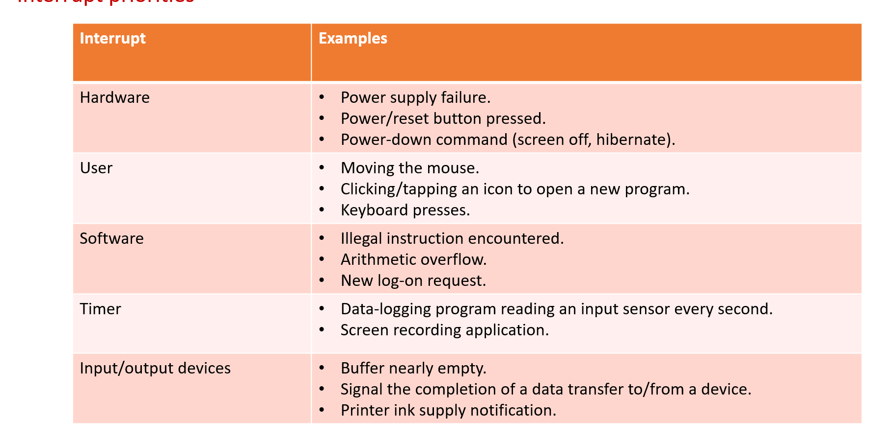

Scheduler
Determines how much time each process will take

Different queuing methods
First come first serve (FCFS) – can be inefficient with a bad order
Shortest job first (SJF) – efficient but needs to know the length before hand
Round robin (RR) – Giving commands a specific amount of time to be finished. If its not finished, it loops back.
Shortest remaining time (SRT) – same as the other except now we have a priority system.
MLFQ – multiple queues, each with different priorities.

In distributing OS – the computer coordinates OS`s to make it seem like a single system

EMBEDDED SYSTEMS
Devices that are made for a specific purpose, bringing great eeeefficiency

REAL TIME OS
Used when a thing MUST happen in a time period

DEVICE DRIVERS
DD translates OS instructions to print the document in instructions the devide will understand

VIRTUAL MACHINES
Quite literally just emulation

